Internship Studio

Ethical Hacking

**Training + Internship**

TASK1: - To solve any 5 XSS labs from [https://portswigger.net/web-security/all-](https://portswigger.net/web-security/all-labs) [labs](https://portswigger.net/web-security/all-labs).

Lab1: - Reflected XSS into HTML context with nothing encoded

This lab contains a simple Reflected cross-site scripting Vulnerability. We can find this vulnerability in search functionality.

Procedure:

1. Click on access the lab tab
2. In search box type a cross-site script as

<script>alert(1)</script>

1. Enter.

Cross-site script use in search box is:

<script>alert(1)</script>

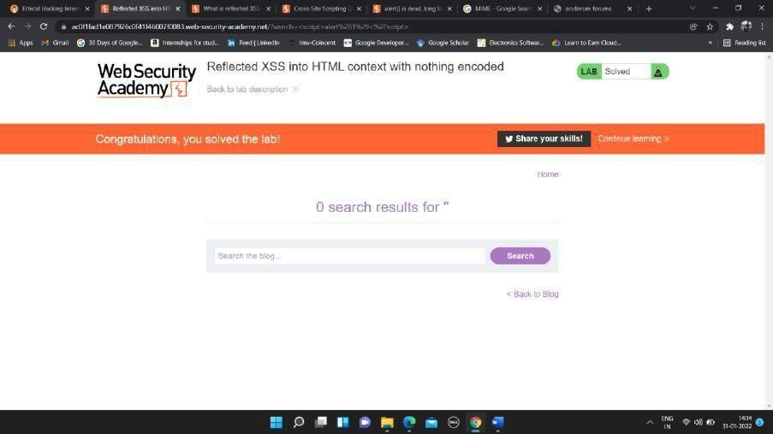

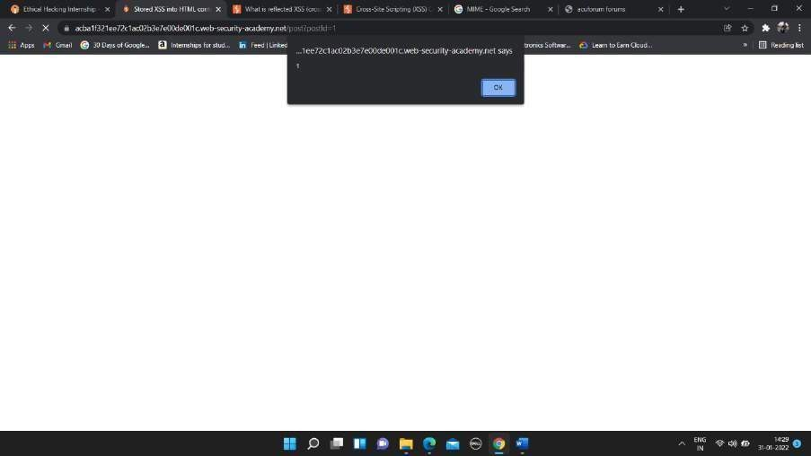



Lab2: - Stored XSS into HTML context with nothing encoded.

# This lab contains the stored cross-site scripting vulnerability. To find this vulnerability we need to write a cross-site script in comment with name, email-id and website name.

In comment box write below script

Cross-site script use:

<script>alert(1)</script>

Procedure:

# Click on tab access the lab.

1. Go to any one of the posts and scroll down to end of the page.
2. In comment box enter the script as

<script>alert(1)</script>

1. Enter the name, email-id, and website name.
2. Click on Post Comment tab.
3. Go back to blog.

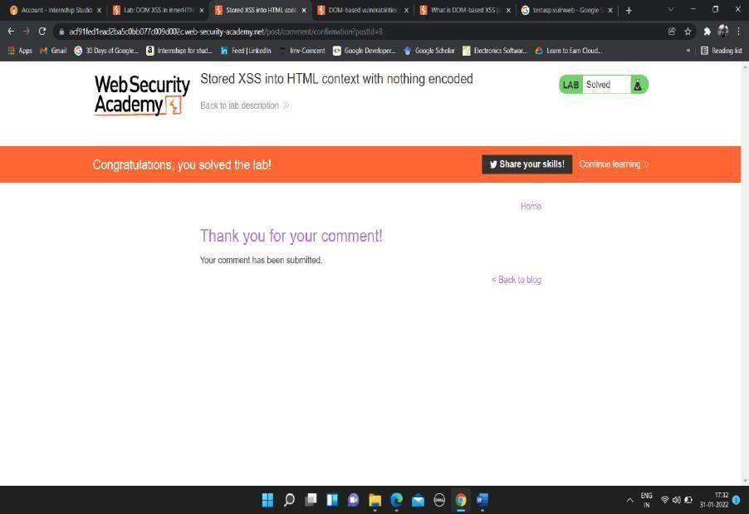

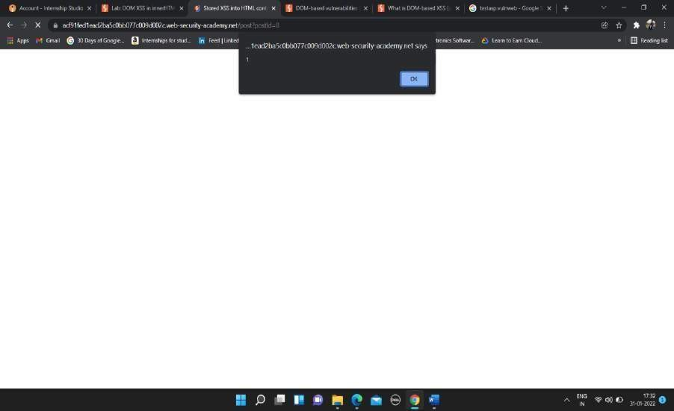



# Lab3: - DOM XSS in document.write sink using source location.search

This lab contains the DOM based cross-script scripting vulnerability in search of query tracking vulnerability. Here I use JavaScript document.write function, which write data out of page. Here in search box the cross-site script is written to find the vulnerability.

Write below cross-site script in search box

“><svg onload = alert(1)>

Procedure: -

1. Click on access the lab tab.
2. Click on submit feedback tab.
3. In search box type cross-site script as

“><svg onload=alert(1)>

1. Click Enter.



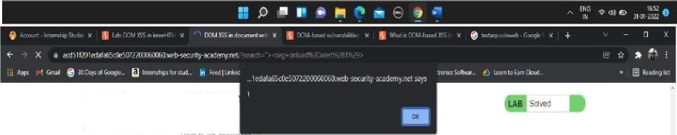

WebSecurit

Aademy

DOklXSSi’





# Lab4: - DOM XSS in innerHTML sink using source location.search

This lab contains the DOM based cross-site scripting vulnerability in the search box functionality. It usesan innerHTML assignment, whichchangesthe HTML contents of a div element, using data from location.search.

Cross-site script use in search box is

<img src onerror=alert(1)>

Procedure: -

1. Click on tab access the lab
2. In search box type <img src onerror=alert(1)> a cross-site script
3. Enter.

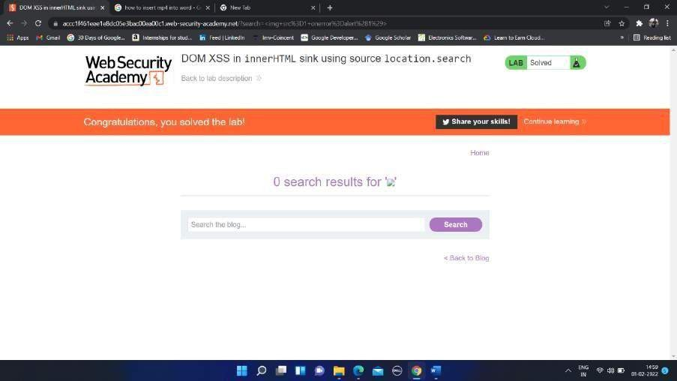

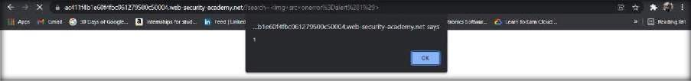



# Lab5: - DOM XSS in jQuery anchor href attribute using location.search source

This lab contains a [DOM-based cross-site scripting](https://portswigger.net/web-security/cross-site-scripting/dom-based) vulnerability in the submit feedback page. It uses the jQuery library's $ selector function to find an anchor element, and changes its href attribute using data from location.search.

Procedure: -

1. Click on access the lab tab.
2. Click on Submit feedback icon.
3. You will next page with URL as **https://ac671fae1fec9f86c0634336007900ee.web- security-academy.net/feedback?returnPath=/**
4. Here cross-site scripting is done in url of the lab
5. Click on URLs and after the

**returnPath= type javascript:alert(1).**

Final URL will be **https://ac671fae1fec9f86c0634336007900ee.web- security- academy.net/feedback?returnPath=javascript:alert(1)**

1. Press Enter.

Cross-site script use in url is

javascript:alert(1)

